Lab 6.2 – Maximo Antigua UPDATED

Refer to Tutorial 6: Working with Tables and Columns

1. Complete Session 6.2 pages HTML 478 to HTML 504

Add a screenshot of the **dir_lw0414.html** file displayed in a browser after completing Step 2 on page HTML 500. Refer to Figure 6-44. Include the browser address bar.

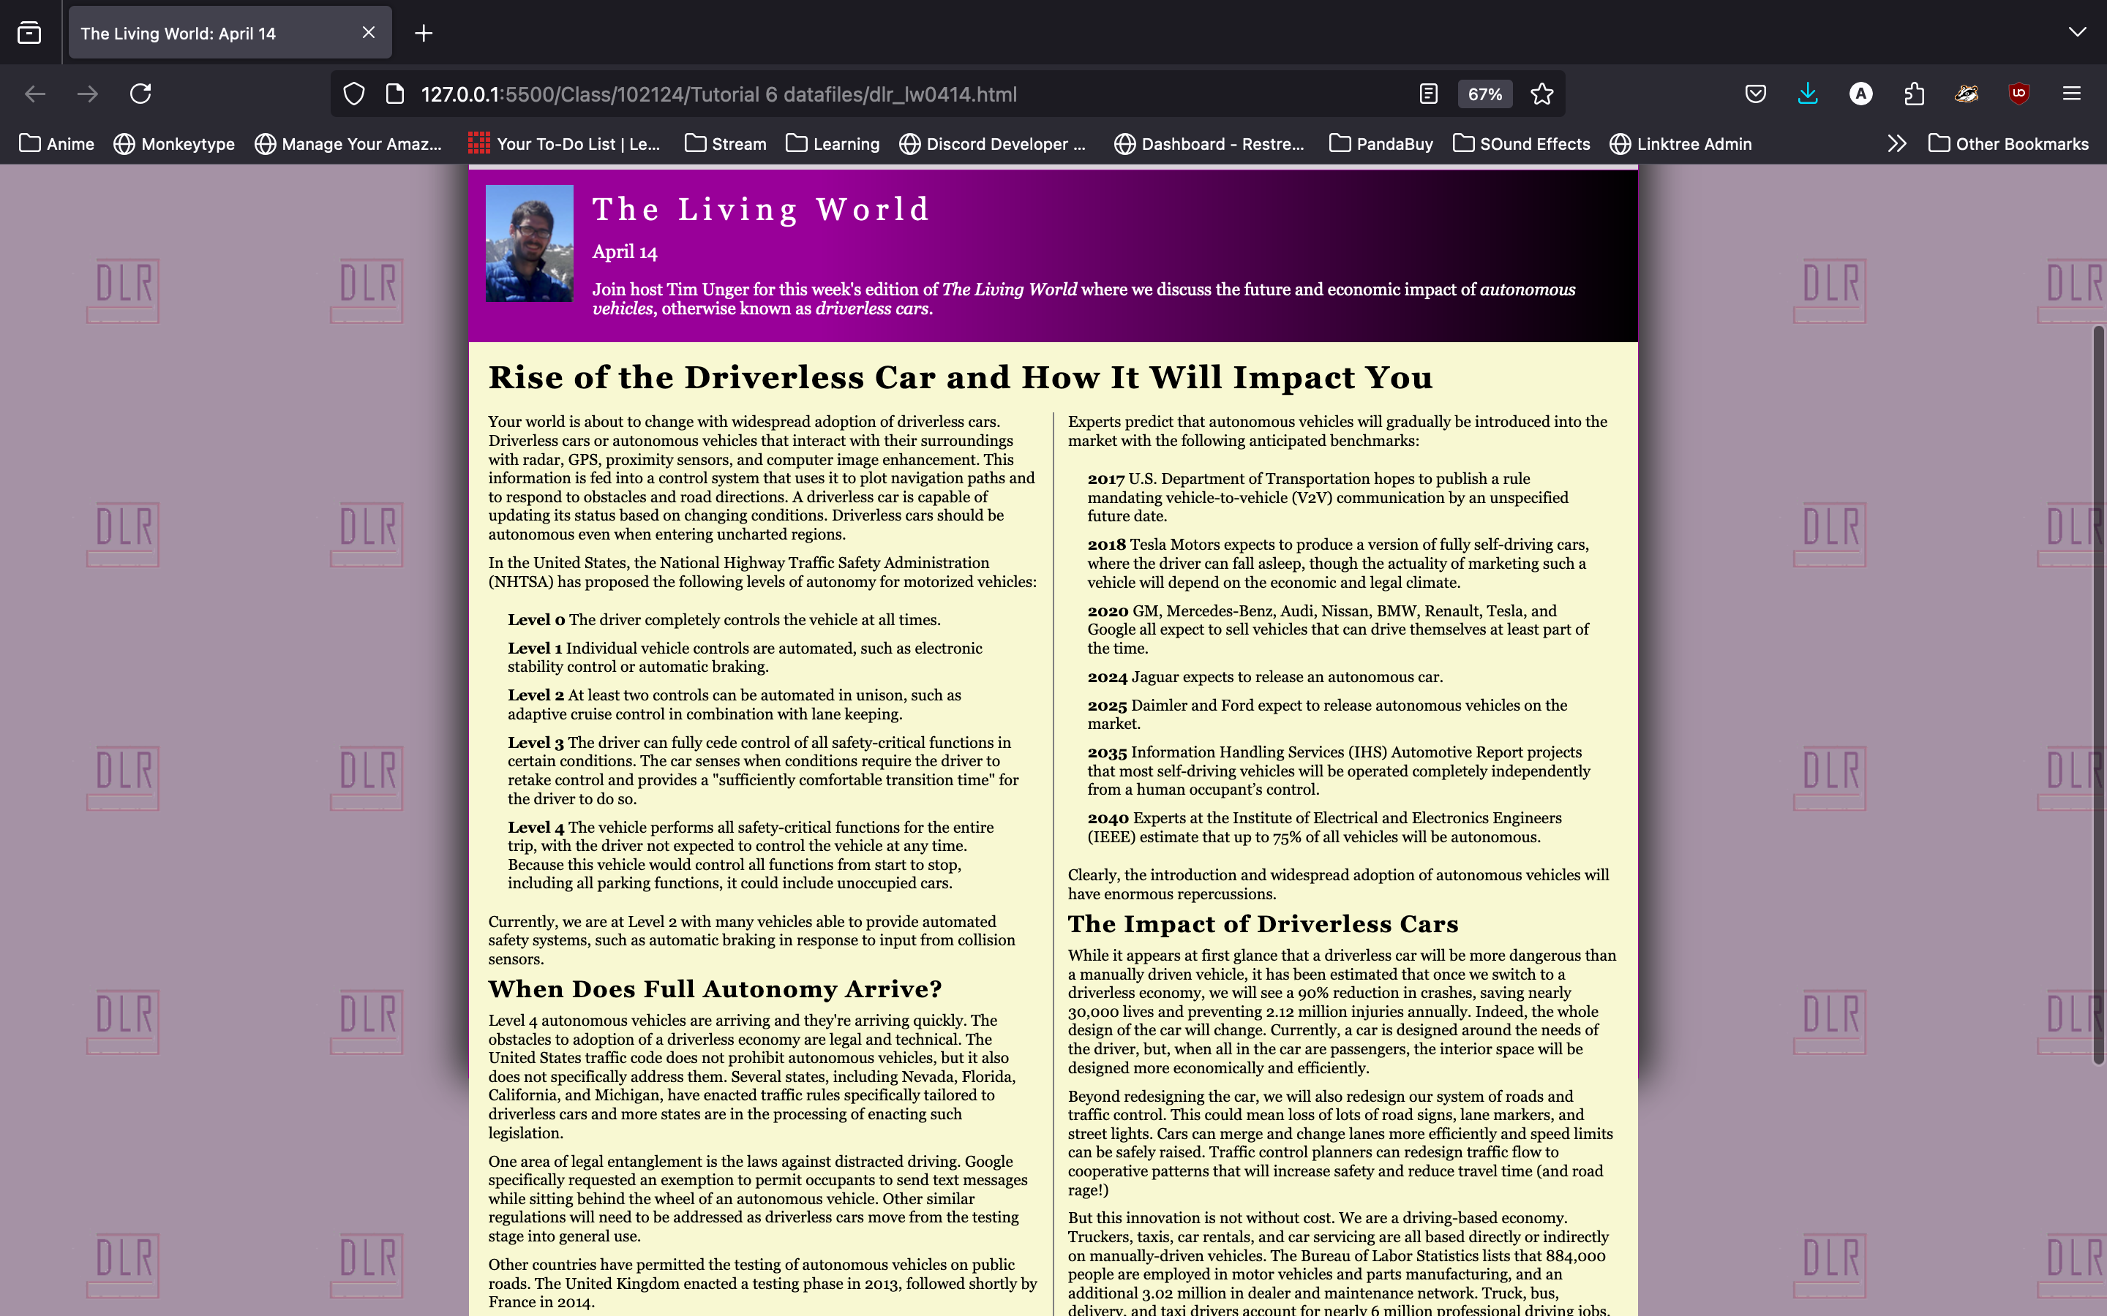

1. Complete the Session 6.2 Quick Check